Income vs. Total Property Cost:

We wanted to compare the median income of borrowers to the median cost of homes in the Southeast for 2009-2018. As the graph below shows, property costs have increased at a higher rate than incomes. This indicates homeownership may be becoming less affordable.

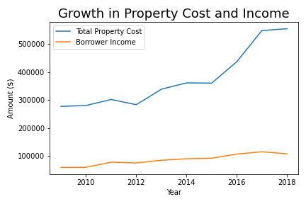

The box and whisker plots of income and house price offer a more in-depth look at affordability trends. The minimum income of borrowers is essentially stagnant, meaning those with lower incomes have not experienced an increase in income. Conversely, the median, maximum and IQR of income increases some from 2009 to 2018, so wealthier people have had some income growth. Still, growth in home prices is higher than the income growth. The median value and IQR of the home price increases every year aside from a slight dip in 2018.

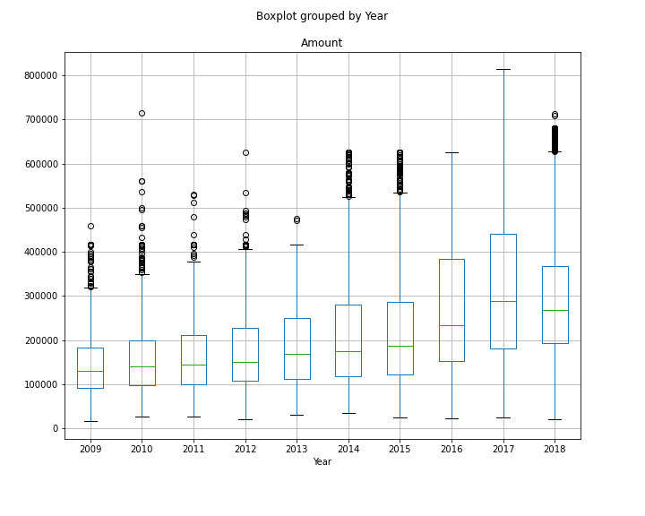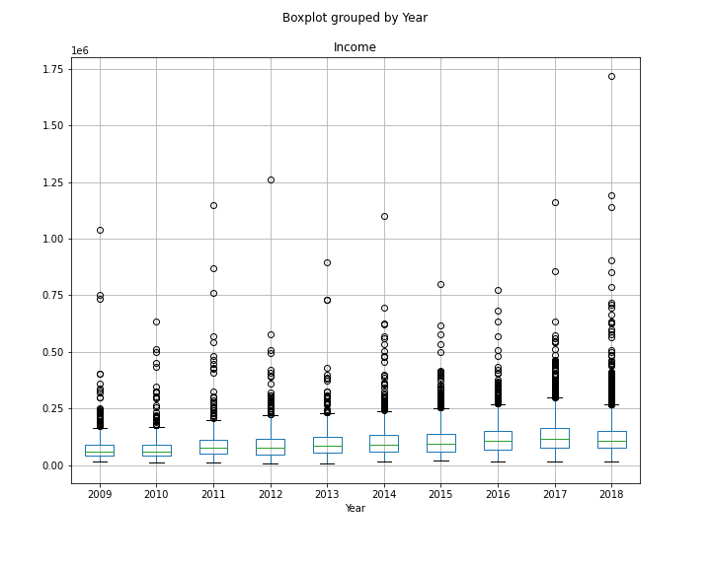

Demographic of buyer - age/race:

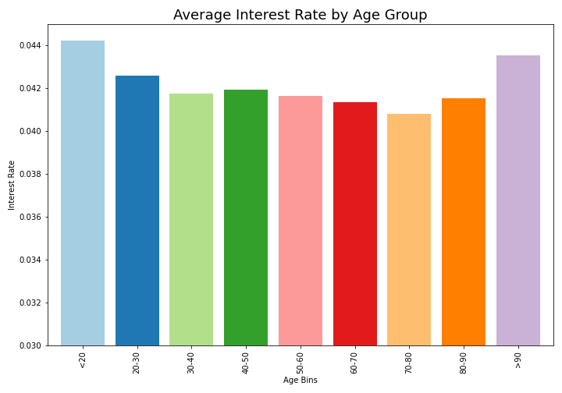

Although interest rates have been historically low during this time period, there are still trends showing different age groups with higher rates. The under 30 and 90+ groups have the highest rates, indicating they are riskier age groups than the rest. The 70-80 age group has the lowest average interest rate.

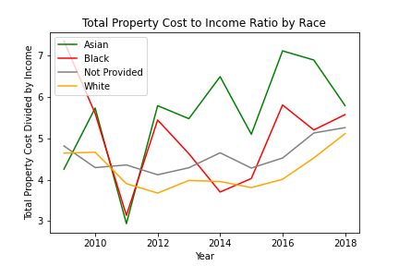

The total property cost vs income by race shows a bit of a different picture for affordability.

White people spend the least amount of their income on housing compared to other demographics. Black people are not spending as much of their income on housing as they were in 2009, but the trend is increasing back up.

Change in total cost of loan by state per year:

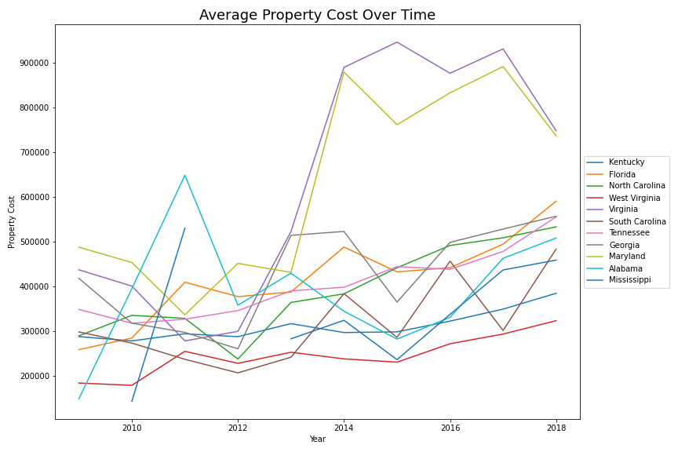

The average property cost by state shows that over the past 10 years, property costs have been increasing for all states. Property costs for Maryland and Virginia had a large increase between 20012 and 2014. This increase makes housing less affordable in those two states.

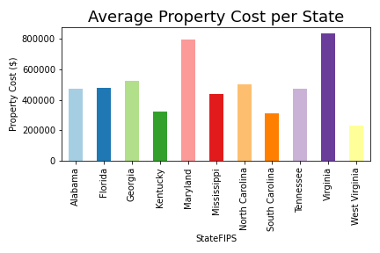

The average property cost per state shows that Virginia and Maryland have the highest property cost. West Virginia has the lowest property cost out of all the states. Alabama, Florida, and Tennessee all have a similar property cost value. The three states that seem to be more affordable are West Virginia, South Carolina, and Kentucky.

Conclusions and Implications:

1. Housing costs have increased significantly even taking the housing crisis from 2009-2012 into account. Income has remained mostly stagnant, with the increases happening to higher earners.
2. Interest rates are higher for the youngest demographic (less than 20), as well as the highest (90+).
3. West Virginia, South Carolina, and Kentucky are the least-expensive states in the Southeast.
4. The more income people spend towards home ownership, the less affordable home ownership becomes. The combination of stagnant wages and increased property values may make home ownership less attainable.